Compliance training process

Access is requested for student including VLS
Student
- Follow directions to set up Entrust (OTP) - attached
- Go to https://www.virtua.org
- Scroll to the bottom of the page
- Select FOR EMPLOYEE
- Select Virtua Network
- Follow directions to log into the Virtua Network.
- Citrix will need to be set up on your personal computer
- For additional assistance setting up Citrix AFTER you have followed directions, please contact the Virtua Help Desk : 1-856-355-1234

Select the directions for setting up Citrix that fit your home computer if you need assistance
- Either Citrix Windows Instructions OR Citrix Receiver for Apple-Mac
- Follow directions

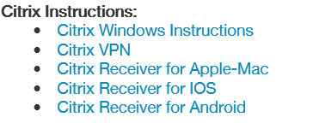
- Select the icon Virtua Learning System
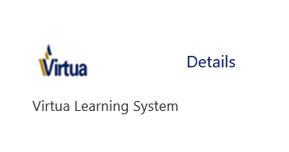
- Search Virtua Compliance Training 2018 – 2 parts
- Select the training that fits your clinical placement AND the compliance training for ALL EMPLYEES
- Complete ALL portions of the training

